LS3: Communication
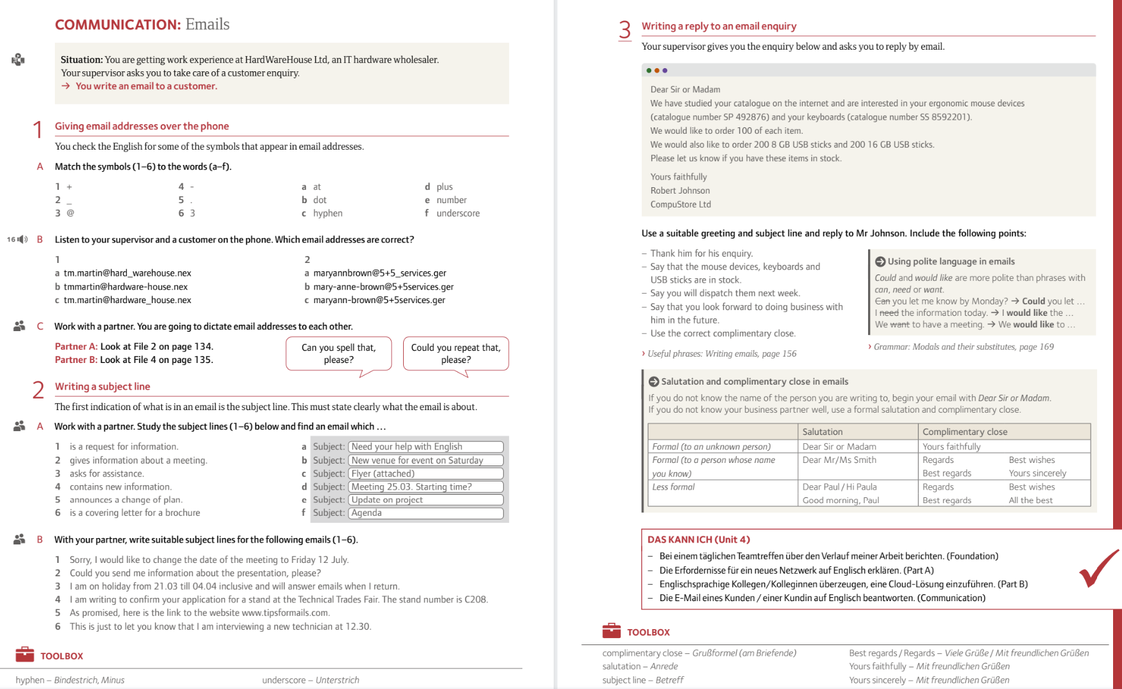

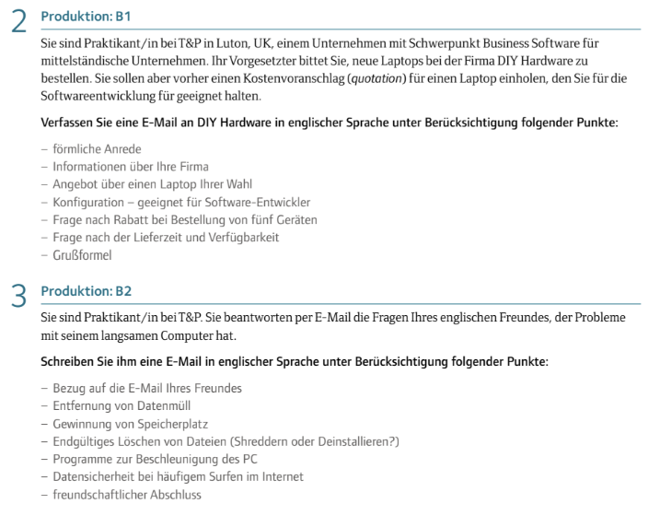

Email Section | Useful Expressions
Opening / Greeting | - Dear [Name],- Hello [Name],- Good morning/afternoon [Name],- To whom it may concern,
Reference / Context | - I am writing regarding…- Further to our conversation…- With reference to…- I am contacting you about…
Purpose / Main Point | - I would like to inform you that…- I am pleased to announce…- I am reaching out to request…- Could you please confirm…
Polite Requests | - Could you kindly…- I would appreciate it if you could…- Would you mind…- Please let me know if…
Offering Help | - Please do not hesitate to contact me if…- I would be happy to assist with…- Let me know if you need any further information.
Apologies | - I apologize for the inconvenience.- Please accept my apologies for…- Sorry for the delay in responding.
Closing (Action) | - I look forward to your reply.- I await your confirmation.- Thank you in advance for your cooperation.
Sign-off | - Best regards,- Kind regards,- Sincerely,- Yours faithfully, (formal, when recipient unknown)

